Project Plan2

I am planning to develop a piano practice application. The application will be launched in the landscape mode as a default, it also only works in landscape like any other piano-related applications. This strategy makes sense because the original user experience of physical piano is horizontally long, with set of black and white keys wide. The application does not simply list keys that generate designated tune of the key, the upper part of application shows musical note a line at a moment, while the vertical bar moves left to right, in the direction to read a musical note, indicating where to hit the key at the moment.

With the recording button, users will be able to record what they played, and listen to how good/bad they were. Whenever user decides to practice a song, they will be able to play the original first, from the alert (or possibly by the default “listen the original” button, as alert distract the user experience through the small screen). The application consists of multiple views, master-detail view, to let user choose song they hope to play. In this case, I will need to use info.plist to store song lists and notes for data persistence.

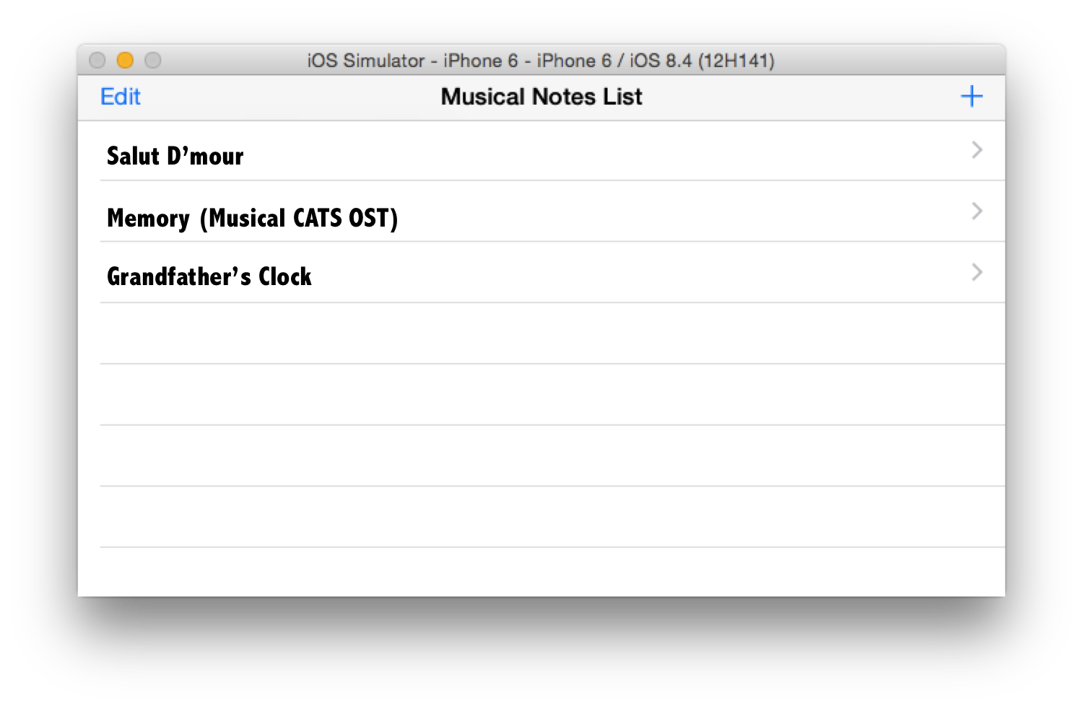

Image1. Master view – choose

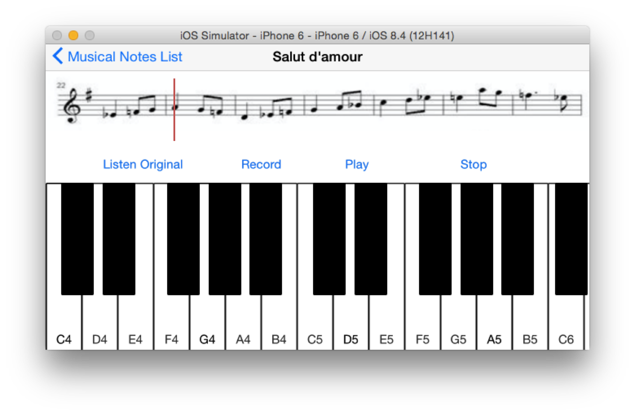

Image2. Detail view of a chosen song to practice. At the top of screen, it shows a line of musical note at a time, with the red vertical bar moving left to right, indicating the timing to hit a key. As the bar hits the end of line, the note will be automatically replaced with next line of note.

This application will possibly be the base form of UI for the grad students’ project, which Danny and I plan to co-work together, to control physical music instruments through the Bluetooth framework.